HOLE IN ONE SPONSOR - $20,000
- Entry for up to 5 teams (max 5 people per team)
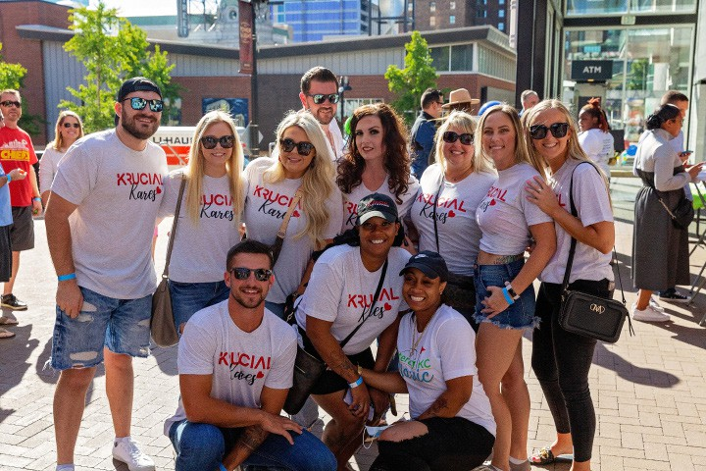
- Hole sponsor - signage at two holes on mini golf course
- Team can pick a golf hole theme or design
- Ability to request a specific caddy
- Logo recognition in all marketing materials promoting event
- Stage Sponsorship - signage on main stage
- Preferred Tee Time
- Thirty (30) second company highlight on KC Live!
stage – can be in person or with a video
- Recognition on literacykc.org, newsletter, Press Release, Literacy KC Annual Report, etc.
- Exclusive social media shout out
- Unlimited access to the Snack Bar
- Unlimited access to the Classic Bar (beer, wine, & signature cocktail)

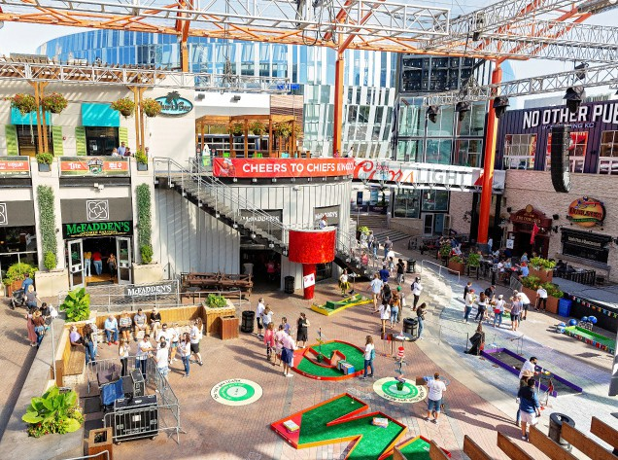
BIRDIE SPONSOR - $10,000
- Entry for up to 3 teams (max 5 people per team)
- Hole sponsor - signage at one hole on mini golf course
- Team can pick a golf hole theme or design
- Ability to request specific caddy
- Logo recognition in all marketing materials promoting event
- Recognition on literacykc.org, newsletter, and Literacy KC Annual Report
- Unlimited access to the Snack Bar
- Unlimited access to the Classic Bar (beer, wine, & signature cocktail)

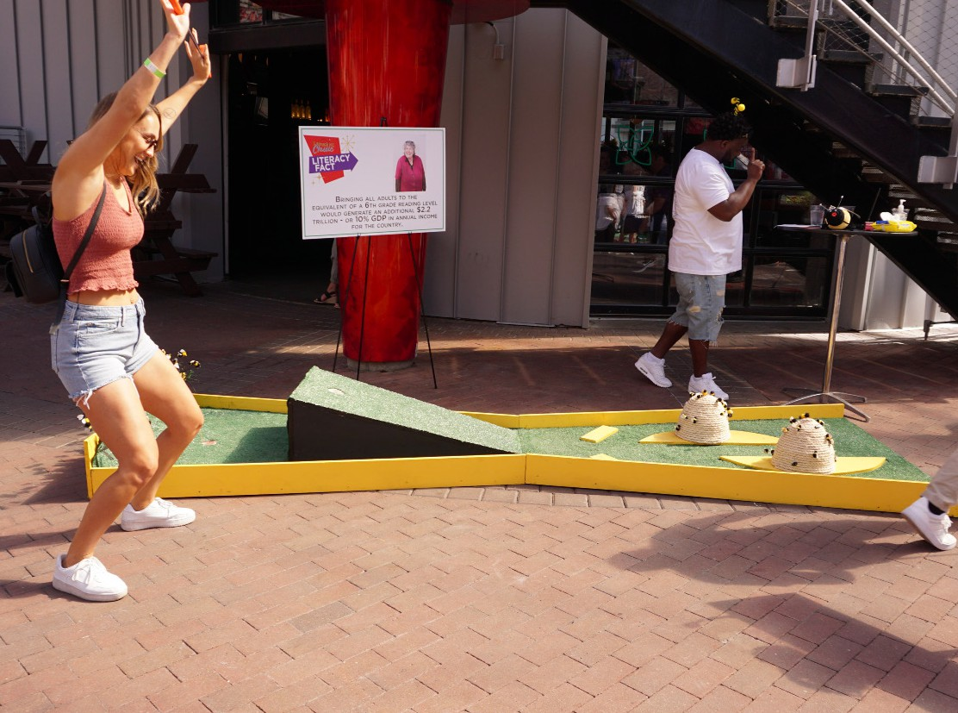
LONG DRIVE SPONSOR -$5,000
- Entry for up to 2 teams (max 5 people per team)
- Hole sponsor - signage at one hole on mini golf course
- Team can pick a golf hole theme or design
- Ability to request a specific caddy
- Logo recognition in all marketing materials promoting event
- Recognition on literacykc.org, newsletter, and Literacy KC Annual Report
- Unlimited access to the Snack Bar
- Unlimited access to the Classic Bar (beer, wine, & signature cocktail)

CLOSE APPROACH SPONSOR - $2,500
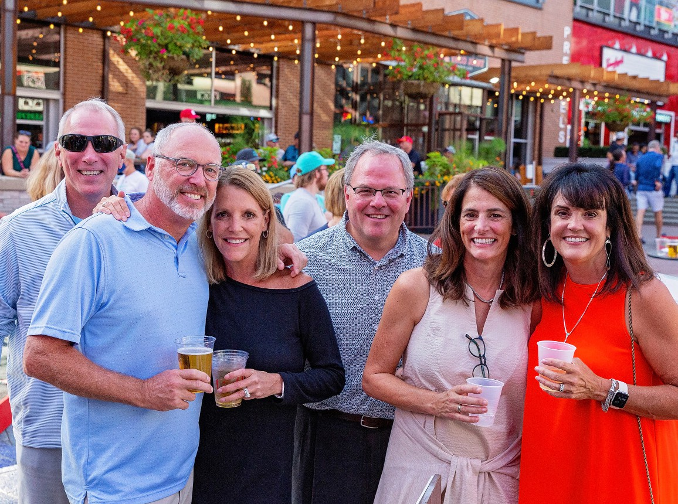
- Entry for one team of 5 players
- Logo recognition in all marketing materials promoting event
- Recognition on literacykc.org, newsletter, and Literacy KC Annual Report
- Unlimited access to the Snack Bar
- Unlimited access to the Classic Bar (beer, wine, & signature cocktail)

TEAM ENTRY - $500
- Entry for one team of 5 players
- Unlimited access to the Snack and Beverage Bars
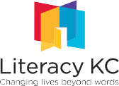
- Recognition on social media

SPONSORSHIP FORM

I’D LIKE TO RESERVE A TEE TIME!

$20,000 | HOLE IN ONE SPONSOR
$5,000 | LONG DRIVE SPONSOR

$10,000 | BIRDIE SPONSOR

PAYMENT INFORMATION
$2,500 | CLOSE APPROACH SPONSOR

$500 | TEAM ENTRY

CHECK ENCLOSED, PAYABLE TO LITERACY KC

SEND ME AN INVOICE.

CREDIT CARD CARD TYPE:
NUMBER: CARDHOLDER NAME:

SECURITY CODE: EXP. DATE:

BILLING ADDRESS:

CONTACT INFORMATION

NAME: TITLE:
EMAIL: COMPANY:

ADDRESS:
PHONE:
